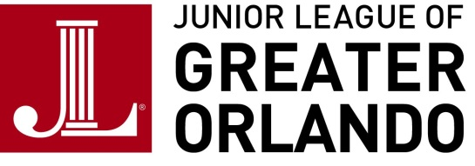
Sponsorship Request for Information

YES, please send additional information to …

Company/Individual Name:

Contact Person:

Phone Number:

Address:

City: State:

Zip Code:

JLGO Member Contact:

My company has a Corporate Gift Matching Program. YES NO

I am not interested in a sponsorship at this time, but would like to find out other ways to support.

Please mail, fax or email all requests to:

Junior League of Greater Orlando Inc.
Attn: Finance VP
2010 North Orange Ave.
Orlando, FL 32804
Fax: 407-898-1702
E-mail: financevp@jlgo.org

