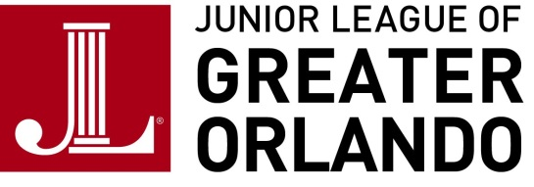
Company/Individual Name: _________________________ Contact: _________________________________

Phone Number: _________________________________Fax Number: _________________________________

Address: _______________________________________City:_______________________________________
State: _______ Zip Code: ______________ Email Address: ______________________________

Please choose the desired Sponsorship Level for cash or in-kind donation:
❑ Champion for Women & Children ($15,000 and above)
❑ Guardian for Women & Children ($10,000 and above)
❑ Advocate for Women & Children ($5,000 and above)
❑ Partner of Women & Children ($2,500 and above)
❑ Supporter of Women & Children ($1,000 and above)
❑ Friend of Women & Children ($500 and above)
❑ A La Carte Option Children ($____)
In-kind donation (please provide complete description and value of donation):
______________________________________________________________________________________________
PAYMENT INFORMATION (Make checks payable to Junior League of Greater Orlando, Inc)

Cash donation: $____________ In-Kind donation: $____________ Company Gift Match $____________
❑ Pay by check (Check # __________)  Please send bill to above address  Pay by credit card

Credit Card Payment:  M/C  VISA  AMEX Card #:_________________________________

Exp. Date: ____________ Signature: ________________________________________________________
JUNIOR LEAGUE OF GREATER ORLANDO PRINTING AND PUBLICATIONS
❑ Please use the following name (individual, corporation or foundation) for listing in JLGO publications, press releases, and other JLGO printed material, when applicable. Print or type exactly as it should appear. ______________________________________________________________________________________________

❑ I (We) prefer not to be listed in any printed materials.  I am an anonymous donor.

In-Kind Donations -We appreciate your donations and will have several opportunities throughout the year in our publications and on our website to thank you. As a nonprofit organization, we strive to put the funds we raise back into the community through our programs and do not give sponsorship benefits for your donations. Thank you for your understanding.

The Junior League of Greater Orlando, Inc. is a Florida nonprofit charitable organization, qualified under Section501 (c) (3) of the IRS Code. Your contribution is deductible to the extent provided by law.

