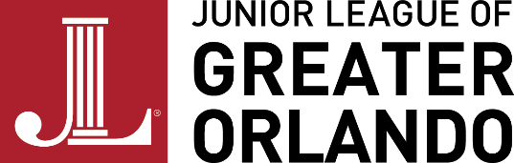

FOR IMMEDIATE RELEASE
AUGUST 18, 2023

Junior League of Greater Orlando Wraps up 75th Anniversary Community Impact Project
$10,000 Donation Given to the Foundation for Foster Children
Junior League of Greater Orlando Completes 75th Anniversary Community Impact Project to the Foundation for Foster Children’s Educate Program
ORLANDO, FLA. – – On Thursday, August 17, the Junior League of Greater Orlando (JLGO) presented a $10,000 donation to the Foundation for Foster Children (FFC) as part of its 75th Community Impact Project. In honor of JLGO's 75th anniversary year, from June 1, 2022 to May 31 2023, the 75th Community Impact Project was designed to raise funds for purchases that directly provide for the needs of a community organization rooted in one of JLGO's issue areas. Throughout the year, this project benefited the Foundation for Foster Children's (FFC) Educate Project. FFC's Educate Program aims to decrease the academic gap among foster children ages 0-14 to improve academic performance and advancement from one grade to the next.
The FFC was created by four friends who were members of the Junior League of Orlando. They saw the needs of foster youth in the community and realized that many don’t receive the support they need. These friends started FFC with the mission to create meaningful connections for foster youth and support their education and lives. FFC continues with that mission and is serving over 1,000 youth in the community with tutoring, resources, advocacy, and many other services. With the help of the over 400 volunteer members of the JLGO, the tools and resources that these youth needed to succeed were acquired.
Donations that were received allowed the League to make purchases of several educational tools to directly help the FFC in their Educate program mission. This was a wonderful opportunity to serve thousands of youths in Greater Orlando through an organization that was started by members of JLGO.
JLGO’s President – Carolyn Haslam Rickert shared “The JLGO’s impact isn’t only expressed in the work our members do with our community partners and programs each year. Arguably its best expression is the cumulative impact of our members, both current and former, in the community outside of the work of the JLGO. The Foundation is an example of that impact and we are glad to support their work.”
# # #
About Junior League of Greater Orlando
The Junior League of Greater Orlando (JLGO) is an organization of women committed to promoting volunteerism, developing the potential of women, and improving the community through the effective action and leadership of trained volunteers. Our purpose is exclusively educational and charitable. To learn more about their efforts in the Greater Orlando community, visit www.jlgo.org.
MEDIA CONTACT
Alex Jano, VP Marketing and Communications
Junior League of Greater Orlando
marketingvp@jlgo.org

