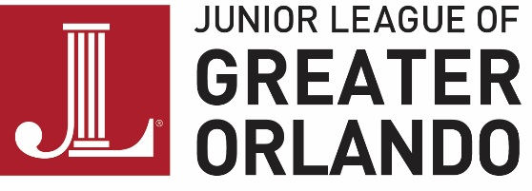

THE BARGAIN BOX
The Junior League of Greater Orlando, Florida, Inc.
2010 North Orange Ave
Orlando, FL 32804
407-898-1700
www.jlgo.org

BARGAIN BOX RECEIPT

Date: |  | League Year:
Member Status: | ❑ Active | ❑ Provisional | ❑ Sustainer | ❑ Donor
Donation Type | ❑ Quota | ❑ Donation

Please Print:
Name:
Address:
Phone:

Merchandise Data:
Item Description | Quantity | Donation Amount ($)
Number of Hangers
Number of boxes
Number of Bags
Other Items
Other Items
Other Items
Other Items
Other Items
Total

The Bargain Box acknowledges the item description and quantity of items donated.

Bargain Box Employee: |  | Date:
Donor Name: |  | Date:

The income received from the resale of your donated items helps fund the community and membership training programs of the Junior League of Greater Orlando, Florida, Inc. All donations must be in good resalable condition to be considered for a charitable tax deduction. The Junior League of Greater Orlando is a 501(c)(3) non-profit organization. No goods or services were provided in connection with this donation.

Thank you for your support of the Junior League of Greater Orlando, Florida, Inc.!

